XCM application case

- Model system

XCM type PLC through the servo motor control, to control the workbench place.

2. Parameter settings

⑴ Servo driver parameter settings:

The rated speed of a certain servo motor is 3000[r/min], the feedback pulse of coder is 8192 [pls/rev]. As the speciality of servo motor, in a specific rotate speed, order the pulse frequency f₀ is the same as the feedback pulse frequency P_{B}, then you will educe the following equation：
f_{0:} The order pulse frequency(HZ) (Issued by the XCM)
P_{f:} Feedback pulse (orientation feedback pulse) amount [pls/rev]
P_{B:} The flight lead of ball screw
N₀: The rotate speed of servo motor[r/min]
CMX: The magnification numerator of servo driver order pulse (electronic gear)
CDV: The magnification denominator of servo driver order pulse (electronic gear)

When the servo motor reach the rated rotate speed, XCM need to output the biggest order pulse frequency, here we select 200 KHz. Changes from the previous expressions:
$$\frac{\text{CMX}}{\text{CDV}}=P_{f}×\frac{N0}{\text{60}}×\frac{1}{f_{0}}=\frac{\text{256}}{\text{125}}$$
So, set "CMX=256，CDV=125" in servo magnifier.

⑵ Pulse rate and feed rate
Educe pulse rate and feed rate according to the following steps.
- Pulse rate refer to the pulse number of servo motor rotate a circle, it can calculate pulse rate on the follow formula:
$$A=P_{f}×\frac{1}{\frac{\text{CMX}}{\text{CDV}}}$$

Take the previous value (CMX:256 CDV:125) to the last formula, then you will get the pulse rate.
Pulse rate:$A=\text{8192}\left[{\text{pls}}/{\text{rev}}\right]×\frac{1}{\frac{\text{256}}{\text{125}}}=\text{4000}\left[{\text{pls}}/{\text{rev}}\right]$
2．Feed rate refer to the movement of servo motor axes run a cirle.
When ball screw run a flight lead P_{B}, motor rotate N2 circle, and the transmission ratio of motor and actuator—screw is N1,
Feed rate $B=\text{N1}×P_{B}×\frac{1}{\text{N2}}$
N1: machine transmission ratio
N2: rotate turn number
P_{B:} the rotate speed of servo motor

For practical calculation as follows:
Feed rate $B=\frac{1}{1}×5\left[\text{mm}\right]×\frac{1}{1\left[\text{rev}\right]}=5\left[{\text{mm}}/{\text{rev}}\right]$

⑶ Convert motion quantity to pulse quantity

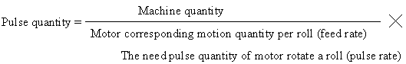

We need workpiece move 200mm, then convert it to pulse quantity:
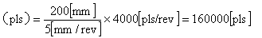
Pulse quantity
So workpiece move 200mm, XCM need to send 160000 pulses.

If we need workpiece move at "30cm/min", then convert it to pulse frequency:
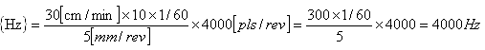
Pulse quantity
So workpiece move at "30cm/min", we need XCM send pulse at the frequency of 400Hz.

- Programme explaination

▲ axis position control operation
Position summarize: position device noly move at the current movement.
● Operate steps
ⅰ：When position device receive startuo order from exterior, it will move in current quantity.
ⅱ：When motion completed, turn-on output Y10.
● Run figure

● Procedure

▲ orientation with reciprocating movement constant
● Position summarize
XCM control workpiece move from left to right, and control workpiece up-down move with eletromagnet.

● Operate steps
  - Only the first time workpiece go back to zero relay to start order.
  - Electromagnet for down move workpiece Y0. When lower-switch X0 turn-on, clamping electromagnet Y1 turn-on, clamp workpiece.
  - After 1.5s, down move electromagnet Y0 disconnect,workpiece move up.
  - When cap-switch X1 turn-on, workpiece move right.
  - When position device achieve right workbench(X2000,Y0), down move electromagnet turn on, workpiece start to move down. When lower-switch X0 turn-on, clamping electromagnet Y1 diaconnect,collect release, put down the workpiece.
  - After 1.5s, down move electromagnet Y0 disconnect,workpiece move up.
  - When cap-switch X1 turn-on, workpiece go back to left workbench.

● Run figure
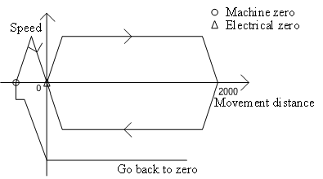

● Procedure
